FEUILLE DE SAISIES DES STATISTIQUES

MATCH CONTRE : DATE : HORAIRE : LIEU :

5– |  |  |  |  | 6– |  |  |  | 7– |  |  |  |  | 8– |  |  |  |  | 9– |  |  | SCORE FINAL : –
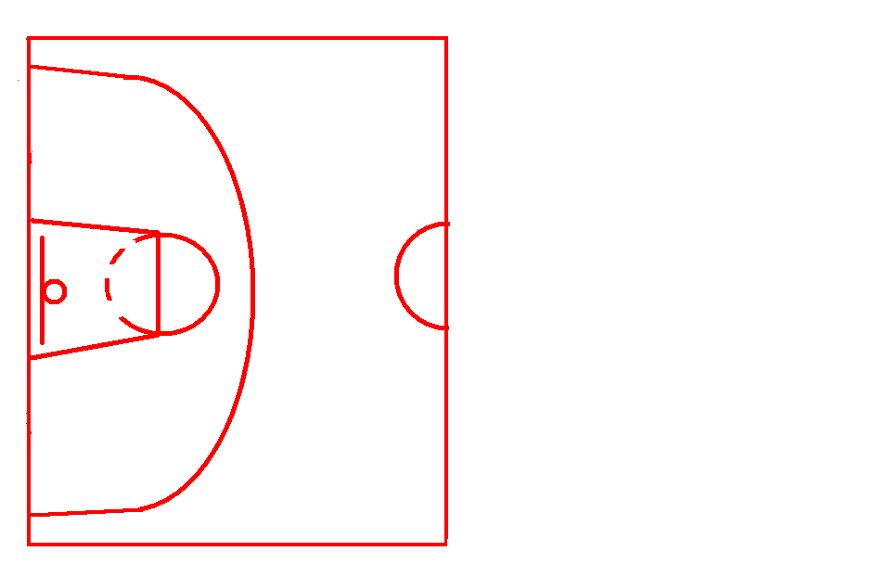 |  |  |  |  |  |  |  |  |  |  |  |  |  |  |  |  |  |  |  |  |  | QT 1 :  QT 2 :  QT 3 :  QT 4 :
INT |  |  |  |  | INT |  |  |  | INT |  |  |  |  | INT |  |  |  |  | INT |  |  | FAUTES
BP |  |  |  |  | BP |  |  |  | BP |  |  |  |  | BP |  |  |  |  | BP |  |  | N° | Locaux |  |  |  | Adversaire
PD |  |  |  |  | PD |  |  |  | PD |  |  |  |  | PD |  |  |  |  | PD |  |  | 4
CON |  |  |  |  | CON |  |  |  | CON |  |  |  |  | CON |  |  |  |  | CON |  |  | 5
RO |  |  |  |  | RO |  |  |  | RO |  |  |  |  | RO |  |  |  |  | RO |  |  | 6
RD |  |  |  |  | RD |  |  |  | RD |  |  |  |  | RD |  |  |  |  | RD |  |  | 7
FP |  |  |  |  | FP |  |  |  | FP |  |  |  |  | FP |  |  |  |  | FP |  |  | 8
T1 |  |  |  |  | T1 |  |  |  | T1 |  |  |  |  | T1 |  |  |  |  | T1 |  |  | 9
T2 |  |  |  |  | T2 |  |  |  | T2 |  |  |  |  | T2 |  |  |  |  | T2 |  |  | 10
T3 |  |  |  |  | T3 |  |  |  | T3 |  |  |  |  | T3 |  |  |  |  | T3 |  |  | 11
Eval |  |  |  |  | pts | Eval |  |  | pts |  | Eval |  |  | pts | Eval |  |  |  | pts | Eval |  | 12
10– |  |  |  |  | 11– |  |  |  | 12– |  |  |  |  | 13– |  |  |  |  | 20– |  |  | 14
 |  |  |  |  |  |  |  |  |  |  |  |  |  |  |  |  |  |  |  |  |  | 15
 |  |  |  |  |  |  |  |  |  |  |  |  |  |  |  |  |  |  |  |  |  | 20
 |  |  |  |  |  |  |  |  |  |  |  |  |  |  |  |  |  |  |  |  |  | STATS CUMULES EQUIPE
INT |  |  |  |  | INT |  |  |  | INT |  |  |  |  | INT |  |  |  |  | INT | - | - | T1
BP |  |  |  |  | BP |  |  |  | BP |  |  |  |  | BP |  |  |  |  | BP | - | - | T2
PD |  |  |  |  | PD |  |  |  | PD |  |  |  |  | PD |  |  |  |  | PD | - | - | T3
CON |  |  |  |  | CON |  |  |  | CON |  |  |  |  | CON |  |  |  |  | CON | - | -
RO |  |  |  |  | RO |  |  |  | RO |  |  |  |  | RO |  |  |  |  | RO | - | - | INT
RD |  |  |  |  | RD |  |  |  | RD |  |  |  |  | RD |  |  |  |  | RD | - | - | BP
FP |  |  |  |  | FP |  |  |  | FP |  |  |  |  | FP |  |  |  |  | FP | - | - | PD
T1 |  |  |  |  | T1 |  |  |  | T1 |  |  |  |  | T1 |  |  |  |  | T1 | - | - | CON
T2 |  |  |  |  | T2 |  |  |  | T2 |  |  |  |  | T2 |  |  |  |  | T2 | - | - | RO
T3 |  |  |  |  | T3 |  |  |  | T3 |  |  |  |  | T3 |  |  |  |  | T3 | - | - | RD
pts |  | Eval |  |  | pts | Eval |  |  | pts | Eval |  |  |  | pts |  | Eval |  |  | Eval | - | - | FP

